SUNDAY 18 MARCH 2018

S. Sudan president expresses optimism at next round of talks.
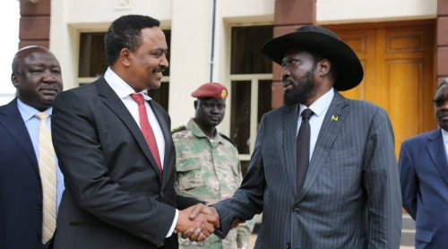 March 18, 2018 (JUBA) - South Sudan president Salva Kiir on Sunday said he was optimistic of positive outcomes at the new round of peace talks, saying all was now geared towards achieving internal peace as well as transformation into a democratic federal republic.
“I am optimistic peace will come to the country soon. There will be a light in the new round of peace talks. We have empowered our team and they will go and negotiate with all opposition groups in good faith,” Kiir told a meeting of the Jieng Council of Elders (JCE) in the country’s capital, Juba.
He said he expects the cooperation of the international community and the region to persuade opposition parties to negotiate in good faith.
“Peace must become because we believe that by negotiating directly and seeking solutions based on a spirit of brotherhood, we would be able to achieve not only a more durable internal unity but also establish the Democratic Republic”, said Kiir.
The South Sudanese told the JCE members that all ethnic groups must negotiate and participate in the national dialogue based on the spirit of brotherhood, “with unqualified trust, unity and firm determination.”
“I have said before that these political processes currently being pursued like the SPLM reunification, revitalization forum and national dialogue are all efforts being rolled out to end this conflict,” said Kiir.
He further stressed, “We are now discussing and seeking solutions for the cessation of all internal armed conflicts and to establish a democratic republic firmly in accordance with the desire of our ethnic national brothers and sisters”.
The president said that without the recognizing the importance of sovereignty, establishing a federal democratic republic, which has been one of the demands of the people, would be out of reach.
He, however, said that for internal peace to be achieved, there should be mutual trust among the 64 ethnic groupings in the country.
South Sudan peace talks stalled last month over a text, mediators and opposition officials wanted to be added to a provision that authorizes levying punitive measures against individuals who violate the peace process.
The second phase of the High-level Revitalization Forum under the auspices of the Intergovernmental Authority on Development (IGAD) was held in the Ethiopian capital, Addis Ababa from 5-16 February.
The second phase mainly discussed the implementation of a permanent cease-fire, which was part of the 2015 peace agreement; elaborate a revised and realistic timeline and a schedule towards general elections at the end of the interim period.
South Sudan has been mired in conflict between the government Kiir and rebels led by ex-Vice President Riek Machar since December 2013. The conflict has killed tens of thousands and displaced almost over 2 million people from their homes, including over a million refugees who fled to neighbouring nations.

